## Reports Menu/Print Images/Pharmacist Report/Counseling Report:

Request:

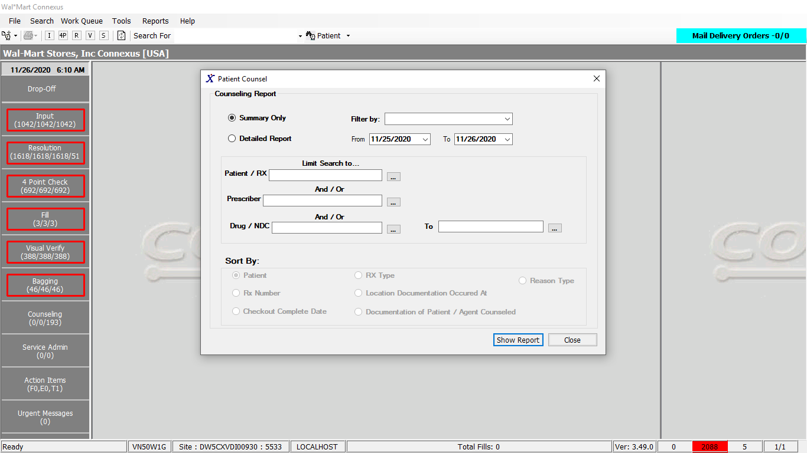

Response:

Detailed Report:

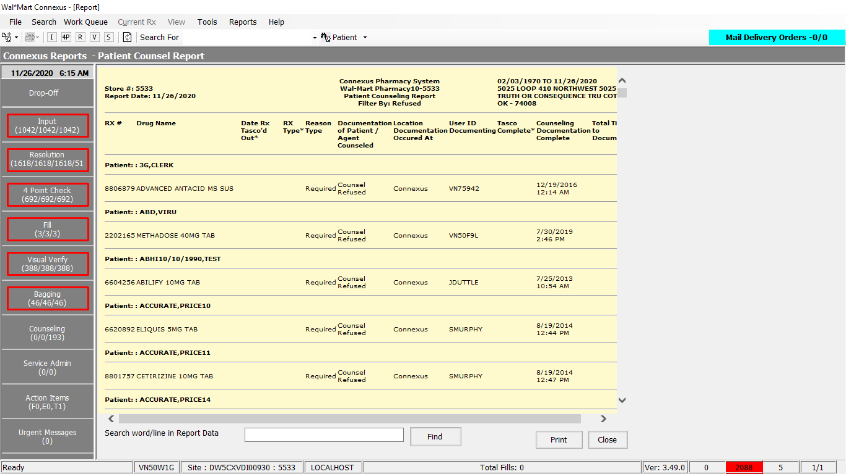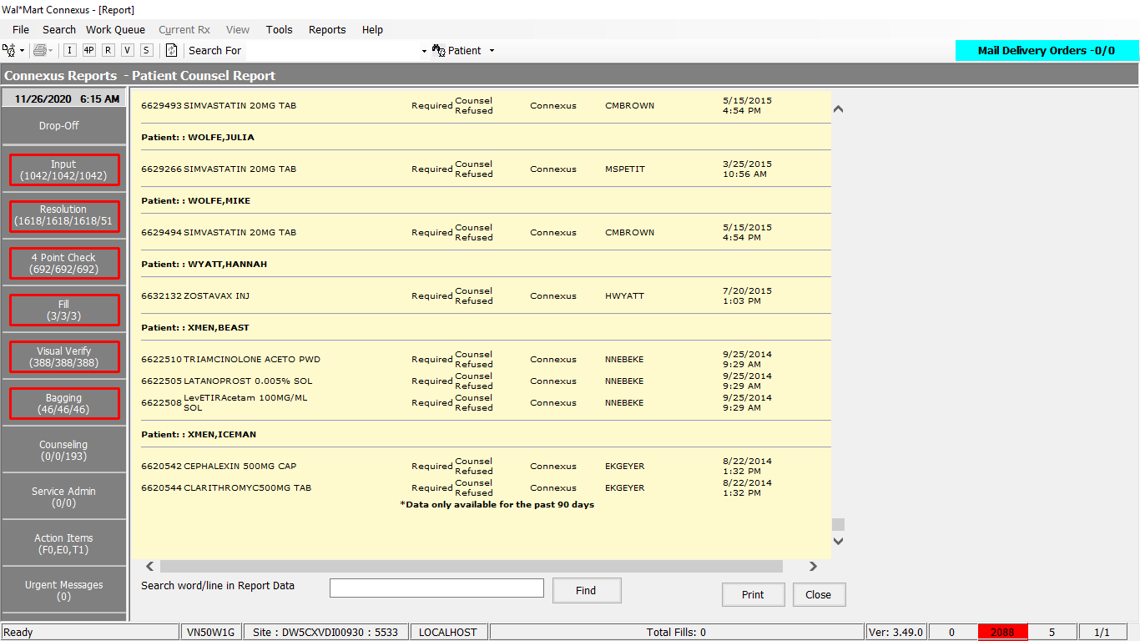

Summary Report:

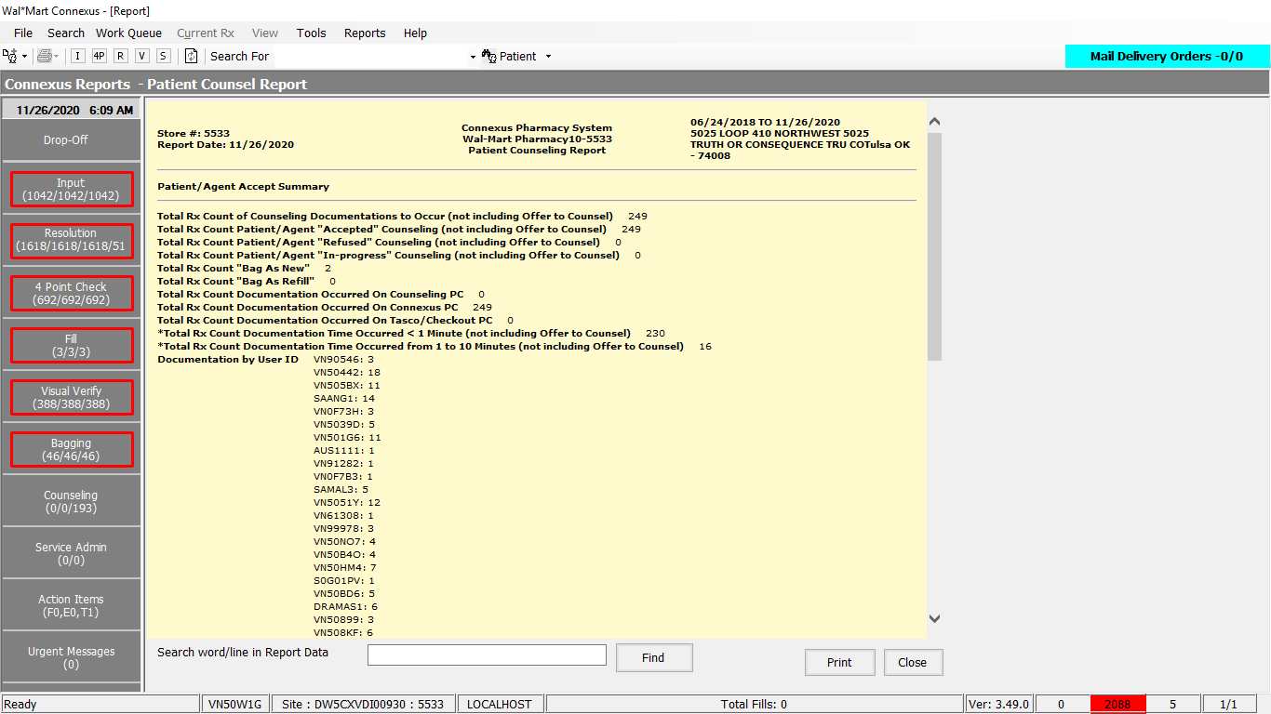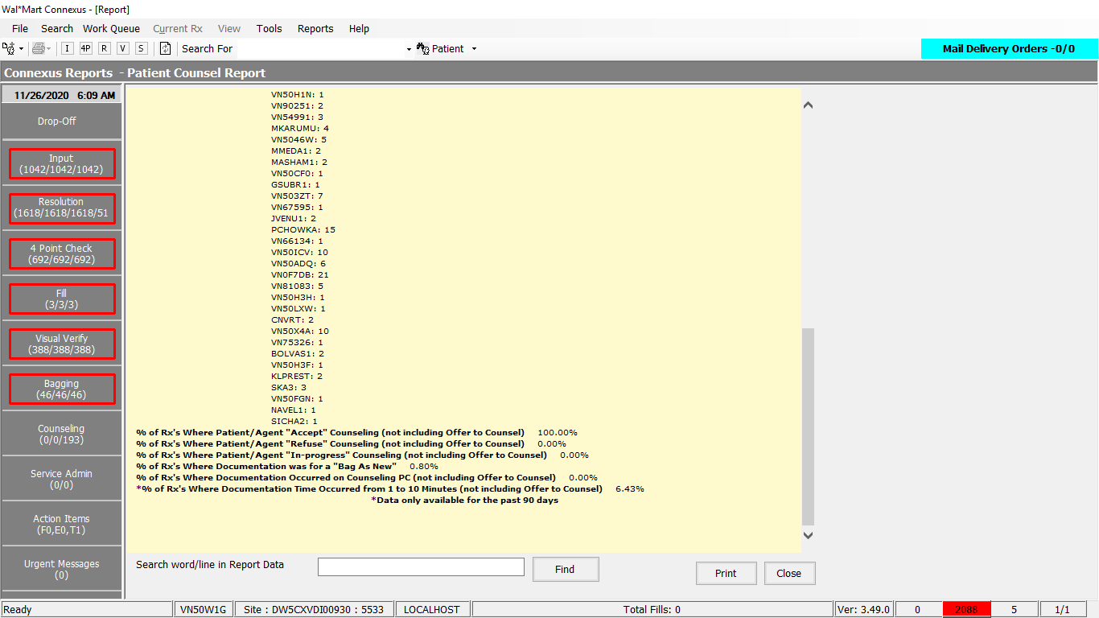

Queries:

1.

Friend Const GetCounselDataSELECT As String = "SELECT rx.rx_id, rf.rx_fill_id, rx.rx_version_seq_nbr, rx.rx_nbr RxNumber, " &

"rf.fill_type_code,pa.patient_id, rfa2.activity_ts counseltime, rfa2.activity_userid, " &

"CASE WHEN rx.compound_ind ='Y' " &

"THEN c.compound_name " &

"WHEN rx.compound_ind !='Y' " &

"THEN pp.short_name " &

"END drug_name, " &

"rxod.request_type_code, pct.code_desc, " &

"TRIM(NVL(pa.last_name,'')) || ',' || TRIM(NVL(pa.first_name,'')) || ' ' || " &

"TRIM(NVL(pa.middle_name,'')) PatientName, rf.pos_ts soldtime, " &

"rxod.actual_pickup_ts tascotime, " &

"CASE WHEN rfa1.activity_code IN (32731,32732,32733,32734,32735,32736,32737,32738,32739,32740,32741,32765) " &

"THEN 'Counsel Yes' " &

"WHEN rfa1.activity_code IN (32742,32743,32744) " &

"THEN 'Counsel No' " &

"WHEN rfa2.activity_code IN (32747,32746) " &

"THEN 'OfferToCounsel' " &

"WHEN rfa2.activity_code IN (32622,1167) OR (rxod.next_work_que_code = 3 AND (rf.pos_ts < CURRENT OR rxod.actual_pickup_ts < CURRENT)) " &

"THEN 'Required' " &

"ELSE " &

" 'Not Required' " &

"END reason, " &

"CASE WHEN rfa2.activity_code = 32747 " &

"THEN 'Offer Refused' " &

"WHEN rfa2.activity_code = 32746 " &

"THEN 'Offer Accepted' " &

"WHEN rfa2.activity_code = 1167 " &

"THEN 'Counsel Refused' " &

"WHEN rfa2.activity_code = 32622 " &

"THEN 'Counsel Accepted' " &

"WHEN (rxod.next_work_que_code = 3 AND (date(rf.pos_ts) < TODAY OR date(rxod.actual_pickup_ts) < TODAY))" &

"THEN 'In Progress' " &

"WHEN (rxod.next_work_que_code = 3 AND (date(rf.pos_ts) = TODAY OR date(rxod.actual_pickup_ts) = TODAY))" &

"THEN 'Pending' " &

"ELSE " &

"'Not Required' " &

"END documentation, " &

"CASE WHEN rfa2.activity_code IN (32622, 1167) " &

" THEN CASE WHEN ((SELECT COUNT(*) FROM rx_fill_activity rfa5 WHERE " &

" rfa5.rx_fill_id = rfa2.rx_fill_id AND rfa5.activity_code = 31007) > 0) " &

"THEN 'Counseling Station' " &

"ELSE 'Connexus' END " &

"WHEN rfa2.activity_code IN (32746,32747) " &

"THEN 'TASCO' " &

"END location, " &

"rxod.next_work_que_code WorkQue "

2. Friend Const GetCounselDataFROM As String = "FROM rx_fill rf " &

" FULL OUTER JOIN rx_fill_activity rfa1 On (rf.rx_fill_id = rfa1.rx_fill_id " &

" And rfa1.activity_ts BETWEEN ? And ? " &

" And rfa1.activity_code In (32731,32732,32733,32734,32735,32736,32737,32738,32739,32740,32741,32765,32742,32743,32744) " &

" And rfa1.activity_seq_nbr In (Select MAX(activity_seq_nbr) " &

" FROM rx_fill_activity rfa3 " &

" WHERE rfa3.rx_fill_id = rf.rx_fill_id " &

" And rfa3.activity_code In (32731,32732,32733,32734,32735,32736,32737,32738,32739,32740,32741,32765,32742,32743,32744)) " &

" ) " &

" FULL OUTER JOIN rx_fill_activity rfa2 On (rf.rx_fill_id = rfa2.rx_fill_id " &

" And rfa2.activity_ts BETWEEN ? And ? " &

" And rfa2.activity_code In (32622,1167,32746,32747) " &

" )" &

" INNER JOIN rx rx On rx.rx_id = rf.rx_id " &

" LEFT OUTER JOIN rx_order_detail rxod On rf.rx_fill_id = rxod.rx_fill_id " &

" LEFT OUTER JOIN pharmacy_code_txt pct On pct.code_id = rxod.request_type_code " &

" INNER JOIN patient pa On pa.patient_id = rx.patient_id " &

" INNER JOIN rx_fill_item rfi On rf.rx_fill_id = rfi.rx_fill_id " &

" INNER JOIN pharmacy_offering:pharmacy_item pi ON pi.mds_fam_id = rfi.item_mds_fam_id " &

" INNER JOIN pharmacy_offering:pharmacy_product pp ON pi.product_mds_fam_id = pp.product_mds_fam_id " &

" LEFT OUTER JOIN rx_compound rxc ON rx.rx_id = rxc.rx_id " &

" LEFT OUTER JOIN compound c ON rxc.compound_id = c.compound_id "

3.Friend Const GetCounselDataWHERE As String = " WHERE rf.status_code = 20401 " &

" AND ((rfa1.rx_fill_id IS NOT NULL OR rfa2.rx_fill_id IS NOT NULL) OR (rfa1.rx_fill_id IS NULL OR rfa2.rx_fill_id IS NULL) ) "

DAL:

Public Function GetCounselData(ByVal reportType As Integer, ByVal sortOption As String, ByVal siteId As Integer,

Optional ByVal rxNbr As Integer = 0,

Optional ByVal patientId As Integer = 0,

Optional ByVal startFillDate As DateTime = Nothing,

Optional ByVal endFillDate As DateTime = Nothing,

Optional ByVal drugNDCFrom As Integer = 0,

Optional ByVal drugNDCTo As Integer = 0,

Optional ByVal filterOptionCode As Integer = 0,

Optional ByVal prescriberId As Integer = 0) _

As List(Of GetCounselDataInfoBE) Implements IReportDAL.GetCounselData

'Declare the method variables

Dim sqlString As New StringBuilder

Dim getCounselDataInfoBEList As New List(Of GetCounselDataInfoBE)

Dim paramList As New List(Of DbParameter)

'Start the method trace

Using (New Tracer(ConnexusCommonConstants.ConnexusTracer))

sqlString.Append(ReportQueries.GetCounselDataSELECT)

sqlString.Append(ReportQueries.GetCounselDataFROM)

sqlString.Append(ReportQueries.GetCounselDataWHERE)

sqlString.Append(AddCounselFilterSQL(filterOptionCode))

paramList.Add(ParameterHelper.BuildParameter("activityTS", DbType.DateTime,

String.Format(CultureInfo.InvariantCulture,

"{0:yyyy-MM-dd 00:00:01}",

startFillDate)))

paramList.Add(ParameterHelper.BuildParameter("activityTS", DbType.DateTime,

String.Format(CultureInfo.InvariantCulture,

"{0:yyyy-MM-dd 23:59:59}",

endFillDate)))

'Added extra parameters to retrieve 1401 data in Counseling report

paramList.Add(ParameterHelper.BuildParameter("activityTS", DbType.DateTime,

String.Format(CultureInfo.InvariantCulture,

"{0:yyyy-MM-dd 00:00:01}",

startFillDate)))

paramList.Add(ParameterHelper.BuildParameter("activityTS", DbType.DateTime,

String.Format(CultureInfo.InvariantCulture,

"{0:yyyy-MM-dd 23:59:59}",

endFillDate)))

If rxNbr > 0 Then

sqlString.Append(" AND rx.rx_nbr = ? ")

paramList.Add(ParameterHelper.BuildParameter("rxNbr", DbType.Int32, rxNbr))

End If

If patientId > 0 Then

sqlString.Append(" AND pa.patient_id = ? ")

paramList.Add(ParameterHelper.BuildParameter("patientId", DbType.Int32, patientId))

End If

If drugNDCFrom > 0 Then

'check if it's a range

If drugNDCTo > 0 Then

sqlString.Append(" AND pp.product_mds_fam_id >= ? ")

paramList.Add(ParameterHelper.BuildParameter("drugFrom", DbType.Int32, drugNDCFrom))

sqlString.Append(" AND pp.product_mds_fam_id <= ? ")

paramList.Add(ParameterHelper.BuildParameter("drugTo", DbType.Int32, drugNDCTo))

Else

'nope, not a range

sqlString.Append(" AND pp.product_mds_fam_id = ? ")

paramList.Add(ParameterHelper.BuildParameter("drugFrom", DbType.Int32, drugNDCFrom))

End If

End If

If prescriberId > 0 Then

sqlString.Append(" AND rx.prescriber_id = ? ")

paramList.Add(ParameterHelper.BuildParameter("prescriberId", DbType.Int32, prescriberId))

End If

sqlString.Append(" AND pos_ts BETWEEN ? AND ? ")

paramList.Add(ParameterHelper.BuildParameter("PosTS", DbType.DateTime,

String.Format(CultureInfo.InvariantCulture,

"{0:yyyy-MM-dd 00:00:01}",

startFillDate)))

paramList.Add(ParameterHelper.BuildParameter("PosTS", DbType.DateTime,

String.Format(CultureInfo.InvariantCulture,

"{0:yyyy-MM-dd 23:59:59}",

endFillDate)))

sqlString.Append(" UNION ALL ")

sqlString.Append(ReportQueries.GetCounselDataSELECT)

sqlString.Append(ReportQueries.GetCounselDataFROM)

sqlString.Append(ReportQueries.GetCounselDataWHERE)

sqlString.Append(AddCounselFilterSQL(filterOptionCode))

paramList.Add(ParameterHelper.BuildParameter("activityTS", DbType.DateTime,

String.Format(CultureInfo.InvariantCulture,

"{0:yyyy-MM-dd 00:00:01}",

startFillDate)))

paramList.Add(ParameterHelper.BuildParameter("activityTS", DbType.DateTime,

String.Format(CultureInfo.InvariantCulture,

"{0:yyyy-MM-dd 23:59:59}",

endFillDate)))

'Added extra parameters to retrieve 1401 data in Counseling report

paramList.Add(ParameterHelper.BuildParameter("activityTS", DbType.DateTime,

String.Format(CultureInfo.InvariantCulture,

"{0:yyyy-MM-dd 00:00:01}",

startFillDate)))

paramList.Add(ParameterHelper.BuildParameter("activityTS", DbType.DateTime,

String.Format(CultureInfo.InvariantCulture,

"{0:yyyy-MM-dd 23:59:59}",

endFillDate)))

If rxNbr > 0 Then

sqlString.Append(" AND rx.rx_nbr = ? ")

paramList.Add(ParameterHelper.BuildParameter("rxNbr", DbType.Int32, rxNbr))

End If

If patientId > 0 Then

sqlString.Append(" AND pa.patient_id = ? ")

paramList.Add(ParameterHelper.BuildParameter("patientId", DbType.Int32, patientId))

End If

If drugNDCFrom > 0 Then

'check if it's a range

If drugNDCTo > 0 Then

sqlString.Append(" AND pp.product_mds_fam_id >= ? ")

paramList.Add(ParameterHelper.BuildParameter("drugFrom", DbType.Int32, drugNDCFrom))

sqlString.Append(" AND pp.product_mds_fam_id <= ? ")

paramList.Add(ParameterHelper.BuildParameter("drugTo", DbType.Int32, drugNDCTo))

Else

'nope, not a range

sqlString.Append(" AND pp.product_mds_fam_id = ? ")

paramList.Add(ParameterHelper.BuildParameter("drugFrom", DbType.Int32, drugNDCFrom))

End If

End If

If prescriberId > 0 Then

sqlString.Append(" AND rx.prescriber_id = ? ")

paramList.Add(ParameterHelper.BuildParameter("prescriberId", DbType.Int32, prescriberId))

End If

sqlString.Append(" AND (rxod.next_work_que_code in (3,15) AND pos_ts IS NULL AND rxod.actual_pickup_ts ")

sqlString.Append("BETWEEN ? AND ? ) ")

paramList.Add(ParameterHelper.BuildParameter("PickupTS", DbType.DateTime,

String.Format(CultureInfo.InvariantCulture,

"{0:yyyy-MM-dd 00:00:01}",

startFillDate)))

paramList.Add(ParameterHelper.BuildParameter("PickupTS", DbType.DateTime,

String.Format(CultureInfo.InvariantCulture,

"{0:yyyy-MM-dd 23:59:59}",

endFillDate)))

Dim counselDataReader As IDataReader

sqlString.Append(" ORDER BY " & sortOption)

Dim str As String = sqlString.ToString()

counselDataReader = ExecuteReader(DatabaseEnum.rx21c,

siteId, sqlString.ToString,

paramList)

getCounselDataInfoBEList = PopulateCounselDEList(counselDataReader, sortOption)

'return the BEList

If getCounselDataInfoBEList.Count > 0 Then

Return getCounselDataInfoBEList

Else

Return Nothing

End If

End Using

End Function

Public Function AddCounselFilterSQL(ByVal sender As Integer) As String Implements IReportDAL.AddCounselFilterSQL

Dim sb As New StringBuilder

Select Case sender

'Modified the query to get the data in counseling report even though the data is purged in rx_order_detail table

Case ServicesCommonConstants.CnlsAccept

' Accepted

sb.Append("AND rfa2.activity_code = 32622 ")

Case ServicesCommonConstants.CnlsRefuse

' Refused

sb.Append("AND rfa2.activity_code = 1167 ")

Case ServicesCommonConstants.CnlsOffer

'Offer to Counsel

sb.Append("AND rfa2.activity_code IN (32746,32747) ")

Case ServicesCommonConstants.CnlsRequired

'Required

sb.Append("AND ((rfa2.activity_code IN (32622,1167) " &

"AND rfa2.activity_code NOT IN (32746,32747)) " &

" OR rfa2.activity_code IS NULL) " &

"AND 0 = (SELECT COUNT(activity_code) FROM rx_fill_activity WHERE rx_fill_id = rf.rx_fill_id AND activity_code IN (32731,32732,32733,32734,32735,32736,32737,32738,32739,32740,32741,32765,32742,32743,32744)) ")

Case ServicesCommonConstants.CnlsYes, ServicesCommonConstants.CnlsBagAsNew

'Counsel Yes

'32731 - Adherence - Over Utilization

'32732 - Adherence - Under Utilization

'32733 - Assess Proper Patient Use

'32734 - Change - NDC, Color, Quantity

'32735 - Change in Therapy

'32736 - Dosing

'32737 - Drug - Disease

'32738 - Duplicate Therapy

'32739 - Interaction(s)

'32740 - Possible Adverse Effects

'32741 - Other

'32765 - No Disease/Allergy Info On File

sb.Append("AND rfa1.activity_seq_nbr = (SELECT MAX (activity_seq_nbr) FROM rx_fill_activity WHERE rx_fill_id = rfa2.rx_fill_id " &

" AND activity_code IN (32731,32732,32733,32734,32735,32736,32737,32738,32739,32740,32741,32765)) ")

Case ServicesCommonConstants.CnlsNo, ServicesCommonConstants.CnlsBagAsRefill

'Counsel No

'32742 - No Change in Therapy

'32743 - Mail Out / Delivery Prescription

'32744 - Nursing Home Patient

sb.Append(" AND rfa1.activity_code IN (32742,32743,32744) ")

Case ServicesCommonConstants.CnlsInProgress

'In Progress

sb.Append("AND rfa2.activity_code Is Null " &

"AND rxod.next_work_que_code = 3 AND (date(rf.pos_ts) < TODAY OR date(rxod.actual_pickup_ts) < TODAY)")

Case ServicesCommonConstants.CnlsIncludeAll

Case Else

' Oi! This is bad.

End Select

Return sb.ToString()

End Function